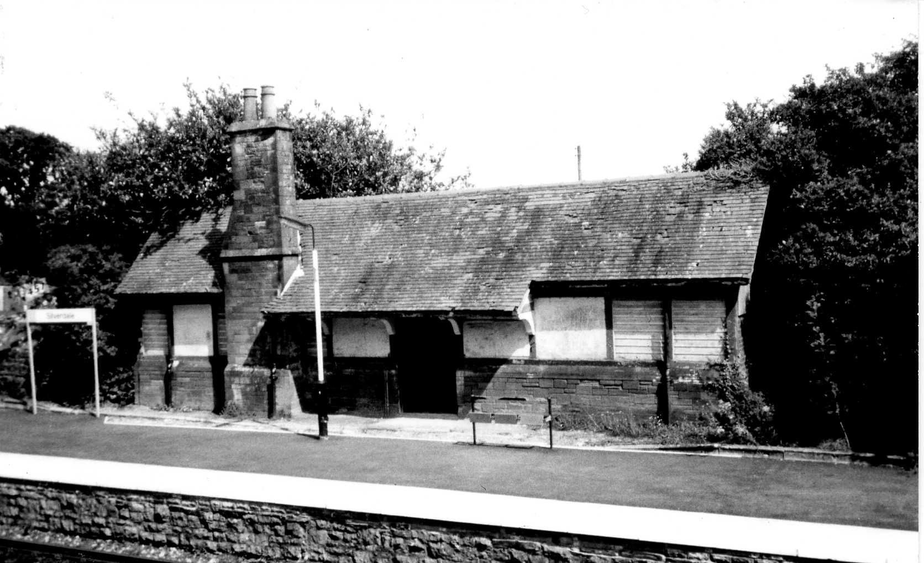
A History of the Waiting Room at Silverdale Station
The opening ceremony of the Ulverstone (sic) and Lancaster Railway (U&LR) was held on 26th August 1857. The single line track ran between Carnforth and Ulverston with stations at Silverdale, Grange, Kents Bank and Cark. Arnside station opened in 1858. The original U&LR buildings on the Barrow platform, which provided the ticket office and other facilities, were designed by Lancaster Architects, Paley and Austin. Much of the building survives and has been converted to residential use.
The line was purchased by the Furness Railway (FR) in 1862 and was dual tracked between 1863-5. A platform was provided at Silverdale for passengers travelling towards Lancaster, but any accommodation would probably have been of a basic wood construction. The Ordnance Survey Map of 1891 shows the platform devoid of buildings.
In 1892 the Furness Railway allocated the money to build the waiting room and work was completed the following year. Although very much in the style of Paley and Austin, whose partnership ended in 1886, it is thought that the design would have been done in-house by the Furness Railway.
The waiting room is built to a surprisingly high specification. The timber frame rests upon a masonry base comprised of sandstone quoins and coping, instead of the more readily available limestone. The roof is tiled rather slated, and the floor is also tiled. There is a ladies waiting room with toilet and open fire, the main waiting room too has an open fire and there is a separate gents toilet. The windows were of stained glass bearing the Furness Railway company logo. Two of the windows rescued from the waiting room are on display in the archive room at the National Railway Museum in York.
The waiting room was built at a time when the Furness Railway faced a decline in its freight revenue and was anxiously looking for ways of making up the deficit. It identified tourism as an opportunity, as the railway opened the Lake District to those benefiting from the growth in family holidays.
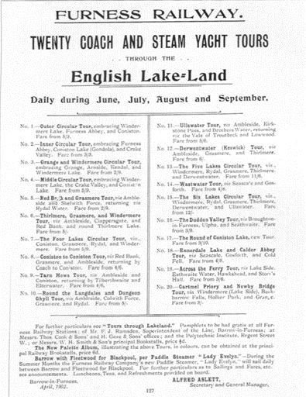
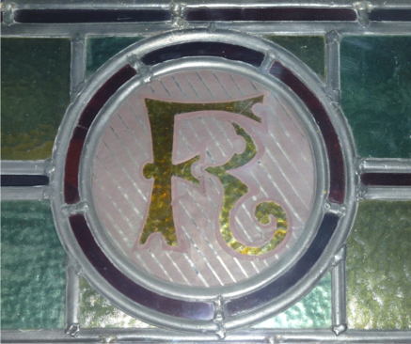
The FR recognised the potential for tourism traffic quite early and had operated steamers on Lake Windermere from 1845, and Coniston from 1860. From 1886 it published extensive holiday guides. The opening of the branch line to Windermere Lakeside in 1869, and the subsequent acquisition of the Windermere Steamers provided the opportunity to offer circular tours utilising the railway and steamers, with horse drawn traps to fill in the gaps. Up to the 1890s only four tours were operated by the company. By 1902 this had grown to twenty, as can be seen from the poster. The FR tours had a great influence on developing the towns it served, particularly Grange-over-Sands.
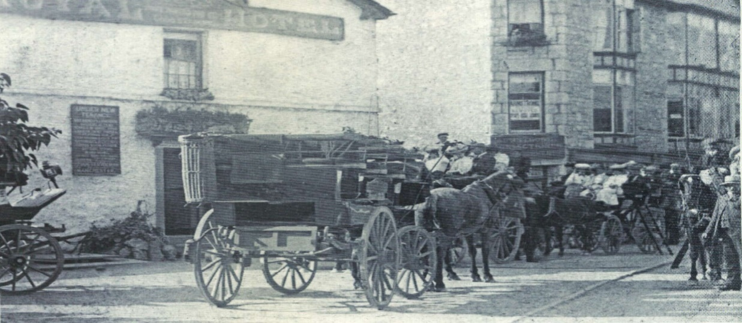
Although Silverdale is not mentioned in the tour itineraries, the village is promoted in other advertising material. ‘Cheap Day Tickets Issued Daily to and from All Pleasure Resorts on The Furness Railway’ were offered to encourage visits to golf courses close to stations along the line. The ‘trippers’ photographed outside the Royal Hotel in Silverdale are being carried in horse-drawn omnibuses typical of those used by the Furness Railway on their tours. From the number being carried, they would, in all probability, have arrived by train.
The policy of increasing passenger growth by promoting the tourist traffic with tours and cheap day return tickets, resulted in a remarkable growth in the number of people travelling by the Furness Railway. From 1895 to the outbreak of war in 1914, passenger numbers doubled to over three million per annum.
Our waiting room was designed to provide comfort and shelter to the tourists and trippers visiting the Silverdale area, and to promote the benefits of travelling by the Furness Railway. The internal walls will have provided space for advertising the company’s services. However, the heyday of our waiting room would have been relatively short. The demands of the Great War meant that railways were committed to supporting war effort, resulting in the end of the tourist trade. The war took a heavy toll on the railway companies, leaving them with old and outdated rolling stock, falling freight revenues and the urgent need for investment. The government decided on a rationalisation of the industry, leading to the Furness Railway being absorbed into the London Midland & Scottish (LMS), the largest of the ‘Big Four’ railway companies.
With the LMS covering such a vast area, the promotion of our local area as a tourist destination lacked priority, and our waiting room would have been used more by everyday travellers. Its use and maintenance declined over the years, and it attracted its fair share of graffiti. When we moved to Silverdale in 2015 the building had been out of use for several years, and was locked and neglected.
‘The Friends of Silverdale Station’ (FOSS) have taken up the cause of saving the waiting room and have had some success in persuading Network Rail and Northern to repair the roof and connect an electricity supply. However, there is concern that the fabric of the building is under threat of damage caused by fly-tipping, and the encroaching vegetation on three of the sides. Most of the masonry base has disappeared beneath it. This can only lead to water ingress and the deterioration of the woodwork within. To ensure the building’s future, FOSS are looking at ways of having the waiting room listed by bodies such as Historic England and The Railway Heritage Trust. If you have any information on the waiting room or experience in applying for listing, FOSS would love to hear from you.
Finally, does anyone have information regarding the origins of the ‘Sunny Silverdale, the Loveliest Spot on Morecambe Bay’ sign that, until recently, was a part of a fence at the station and is now in the custody of FOSS? Is it possible that the sign is a survivor of the Furness Railway’s promotion of the area?

